System Architecture Planning Report
Adaptive Traffic Controller for Two Coordinated Four-Way Junctions
Student name: Shinde Ashok Rajendra
Role: Electronic and robotic intern

This report defines the pre-RTL architecture for two coordinated traffic junctions. It specifies module responsibilities and interfaces, green-wave scheduling, shared pedestrian arbitration, emergency all-red behavior, clock/reset strategy, safety invariants, and a simulation verification plan. No Verilog RTL is included; this document is the planning contract for subsequent implementation.

TABLE OF CONTENTS
1 | Propose and scope
2 | Initial design assumptions
3 | Top-level architecture
4 | Module interfaces and responsibilities
5 | Design rationale
6 | Clocking and reset strategy
7 | Traffic phase sequencing
8 | Pedestrian arbitration
9 | Emergency override contract
10 | Verification plan
11 | Safety invariants
12 | Open decisions and risks to close before RTL
13 | Pre-RTL approval checklist
14 | Conclusion

1. Purpose and scope
This document is the architecture planning contract for an adaptive traffic controller with two coordinated four-way junctions, Junction A and Junction B. It is deliberately pre-RTL: no Verilog implementation is included. The design must provide normal NS/EW sequencing, green-wave coordination, shared fair pedestrian arbitration, and a global emergency all-red response.

2. Initial design assumptions
Values below are proposed starting parameters for planning and simulation. They are not traffic-engineering recommendations for a real road installation.
Parameter | Proposed value | Purpose
Clock frequency | 50 MHz nominal; one common clock for all sequential modules. | Common system clock
Clock period | 20 ns. | Duration of one clock cycle
Nominal NS/EW green duration | 100 clock cycles (illustrative parameter). | Illustrative phase duration
Yellow duration | 10 clock cycles (illustrative parameter). | Transition warning interval
All-red clearance | 5 clock cycles (illustrative parameter). | Clearance between conflicting movements
Green-wave target | B NS green starts 20 cycles after A NS green starts. | Target delay from A NS start to B NS start
Green-wave tolerance | ±2 cycles; valid window is 18–22 cycles. | Permitted scheduling window
Emergency response deadline | Both junctions reach all-red within 3 clock cycles after the defined synchronous emergency-capture event. | Maximum response from synchronous capture
Pedestrian service duration | Configurable; 20 cycles is an illustrative starting value. | Illustrative crossing service interval
Reset | Synchronous, active-low reset sampled on the rising edge of clk. | Common initialization behavior

3. Top-level architecture
Figure 1 shows the logical modules and principal connections. All sequential modules share the same physical clock and reset. The top-level module integrates signals and exposes vehicle lights, pedestrian indications, and diagnostic status.

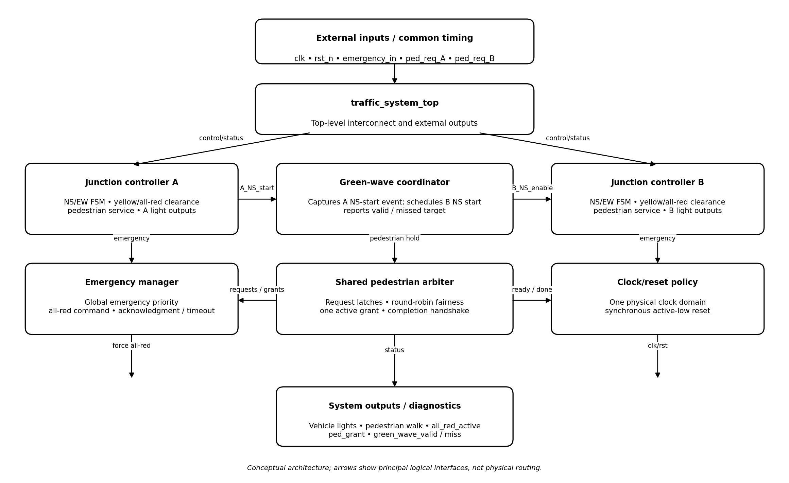
Figure 1. Conceptual top-level architecture (not physical wiring).

3.1 Principal inter-module connections
- A_ns_green_start → green_wave_coordinator → B_ns_green_enable; B's local controller still enforces clearance and safety.
- ped_req_A and ped_req_B → shared pedestrian_arbiter; per-junction grants and pending flags return to the respective local controllers.
- emergency_in → emergency_manager → common emergency_active / force_all_red to both junction controllers.
- clk and rst_n fan out to every sequential module; no module creates a separate clock.
- Junction controllers return all_red, ped_ready, ped_done, and NS-green-start status to the relevant managers.

4. Module interfaces and responsibilities
Signal names are architectural names. Exact widths, encodings, and whether a signal is a pulse or level must be frozen before RTL coding. Unless stated otherwise, all sequential modules use clk and synchronous active-low rst_n.

traffic_system_top
Integrates modules, distributes common clock/reset and emergency status, and exposes all external light and diagnostic outputs.
Signal | Direction | Purpose
clk | Input | Common system clock
rst_n | Input | Active-low synchronous reset
emergency_in | Input | Global emergency request
ped_req_A / ped_req_B | Inputs | Pedestrian request inputs
A_NS[2:0], A_EW[2:0] | Outputs | Junction A vehicle-light indications
B_NS[2:0], B_EW[2:0] | Outputs | Junction B vehicle-light indications
A_ped_walk / B_ped_walk | Outputs | Pedestrian walk indications
all_red_active | Output | Both junctions are in emergency all-red mode
ped_grant[1:0] | Output | Diagnostic grant encoding
green_wave_valid / green_wave_miss | Outputs | Green-wave status and missed-target flag

junction_controller (two instances)
Owns local traffic phase sequencing and safe pedestrian execution. A and B share the same controller design but receive different scheduling inputs.
Signal | Direction | Purpose
clk, rst_n | Inputs | Common clock and reset
emergency_active / force_all_red | Inputs | High-priority emergency override
ns_green_enable | Input | Permission to enter NS green when safe
ped_grant | Input | Arbiter grant for this junction
ped_pending | Input | Request pending indication
ped_ready | Output | Local safe opportunity for pedestrian service
ped_done | Output | Completion acknowledgment
ns_green_start | Output | One-cycle pulse at NS-green entry
phase_state | Output | Encoded FSM state for diagnostics
NS[2:0], EW[2:0] | Outputs | Local vehicle-light indications
ped_walk | Output | Local pedestrian crossing indication
all_red | Output | Local all-red confirmation

green_wave_coordinator
Captures Junction A's NS-green start and schedules Junction B's NS-green start after the configured delay. It never bypasses local safety interlocks.
Signal | Direction | Purpose
clk, rst_n | Inputs | Common clock and reset
A_ns_green_start | Input | A NS-green start event
B_ns_green_start | Input | Feedback confirming B NS-green entry
emergency_active | Input | Cancels/suspends schedule
pedestrian_hold | Input | Indicates coordination is blocked by pedestrian activity
B_ns_green_enable | Output | Scheduled permission for B
green_wave_valid | Output | Target remains valid
green_wave_miss | Output | Target window missed
delay_count | Output | Elapsed cycles since A event

pedestrian_arbiter
Stores requests and fairly chooses the next eligible junction. It controls grants, not vehicle lights.
Signal | Direction | Purpose
clk, rst_n | Inputs | Common clock and reset
ped_req_A / ped_req_B | Inputs | Raw request inputs
A_ped_ready / B_ped_ready | Inputs | Local readiness
A_ped_done / B_ped_done | Inputs | Service-completion acknowledgments
emergency_active | Input | Blocks new grants during emergency
A_ped_pending / B_ped_pending | Outputs | Latched pending flags
A_ped_grant / B_ped_grant | Outputs | Per-junction service grants
ped_busy | Output | A service is active
last_served | Output | Most recently completed junction

emergency_manager
Gives the emergency request highest priority, asserts the common all-red command, and monitors the response deadline.
Signal | Direction | Purpose
clk, rst_n | Inputs | Common clock and reset
emergency_in | Input | External emergency request
A_all_red / B_all_red | Inputs | Junction all-red confirmations
emergency_active | Output | Global emergency state
force_all_red | Output | All-red command to both junctions
emergency_ack | Output | Both junctions confirmed all-red
emergency_timeout | Output | Deadline was missed

clock_reset_manager (logical function)
Documents clock/reset integration; it does not generate another clock. The external clock is wired to all sequential modules.
Signal | Direction | Purpose
clk | Input | Single external system clock
rst_n | Input | Active-low synchronous reset
rst_active | Output | Internal reset status, if needed

5. Design rationale

Why separate modules?
Separation gives each concern a clear contract: local traffic safety, cross-junction timing, pedestrian fairness, and emergency priority can be developed and verified independently. The top level wires modules but does not duplicate policy.

Why share the pedestrian arbiter?
A single arbiter is the authority for both requests and grants. It prevents two independent arbiters from making inconsistent simultaneous decisions and simplifies fairness, diagnostics, and verification. Junction controllers still own local traffic safety.

How simultaneous requests are handled
Both requests are latched. If both are eligible, the arbiter chooses the requester that was not served most recently. It keeps the grant until a completion handshake, then updates the pointer. The other request remains pending.

Starvation assumptions
With two requesters, persistent request latches, finite service time, and eventual readiness, round-robin selection prevents starvation. No finite waiting guarantee is possible if a junction is never safe/ready or emergency mode persists indefinitely.

Green-wave policy
A's NS start event starts a cycle counter. B is permitted at the target delay, but its local controller must also satisfy clearance and safety checks. If constraints prevent B starting by the end of the 18–22 cycle window, the controller reports a miss rather than forcing green.

Emergency policy
Emergency has priority over normal phases, pedestrian grants, and green-wave timing. Both controllers receive a common all-red command. Release requires a controlled recovery/resynchronization sequence.

Clock/reset choice
All sequential logic uses one physical clock. A synchronous active-low reset simplifies single-domain timing analysis and avoids asynchronous state changes. It is sampled on the rising edge; board-level outputs must still default safely before the clock is stable.

6. Clocking and reset strategy
Use one physical 50 MHz clock for all state machines, counters, arbitration logic, and coordination logic. Timing intervals are represented as cycle counts or synchronous clock-enable events; counters must not create derived clocks. This makes cross-module timing deterministic and avoids internal clock-domain crossings.
Use a synchronous active-low reset, sampled on the rising edge of clk. Reset initializes both junctions to all-red, pedestrian walk and grants inactive, pending flags cleared, and the green-wave schedule idle. If emergency_in remains asserted after reset, it must still force the emergency state; reset must not mask an active emergency.
A synchronous reset cannot act before a clock edge. External emergency buttons and pedestrian buttons may be asynchronous and require suitable input conditioning/synchronization. The emergency response deadline must define its timing origin explicitly. Board-level outputs should default to safe states during power-up, including periods when the clock is not stable.

7. Traffic phase sequencing
Each junction has a local FSM with NS_GREEN, NS_YELLOW, EW_GREEN, EW_YELLOW, ALL_RED, and a pedestrian-service state or equivalent service sub-FSM. Normal conflicting movements are separated by yellow and all-red clearance. Emergency override has priority over all normal states. Pedestrian walk may be enabled only after conflicting vehicle movements are stopped and the required clearance is satisfied.

8. Pedestrian arbitration
The arbiter latches requests so a short valid request is not lost. When idle, it selects among pending and locally ready junctions. If both are eligible, it selects the junction not served most recently. The grant remains active until the selected controller acknowledges completion. The other request remains pending. New grants are inhibited during emergency mode.
Fairness guarantee: assuming each service completes in finite time, each continuously pending request eventually becomes ready, and emergency mode does not persist indefinitely, two-requester round-robin arbitration prevents starvation. If a junction is never ready, no arbiter can guarantee a finite service time without an additional timeout/fault policy.

9. Emergency override contract
A single emergency input drives a global emergency manager. On the defined synchronous capture event, force_all_red is asserted and both junctions must display all-red within three clock cycles. emergency_ack is asserted only when both controllers confirm all-red; emergency_timeout indicates a missed deadline. The all-red condition remains active while emergency is asserted. Release does not resume a prior phase automatically; a recovery and resynchronization sequence is required.
At 50 MHz, three clock cycles equal 60 ns. This is an RTL timing target only if the capture path, registered outputs, and downstream hardware can meet it. It must not be claimed as a physical pin-to-light guarantee without a hardware timing and safety analysis.

10. Verification plan
The following scenarios are intended for a self-checking simulation testbench. Each test should record stimulus, expected state/output, and pass/fail status. The suite contains more than the required 15 scenarios.
ID | Scenario | Stimulus / conditions | Expected result
T01 | Startup reset | Assert reset and inspect outputs. | Both junctions all-red; walk and grants inactive; schedule cleared.
T02 | Reset release | Release reset with no requests. | Normal sequencing begins safely; no invalid light encoding.
T03 | A NS phase | Run A through a normal NS phase. | NS green → NS yellow → all-red clearance → EW green.
T04 | B EW phase | Run B through a normal EW phase. | EW green → EW yellow → all-red clearance → NS green only when enabled.
T05 | Long normal run | Run both junctions through multiple cycles. | No conflicting greens; state/counters remain valid.
T06 | Green-wave nominal | No pedestrian or emergency interruption. | B NS green starts 20 cycles after A NS start.
T07 | Green-wave lower bound | Exercise earliest legal timing. | B does not start earlier than 18 cycles after A.
T08 | Green-wave upper bound | Keep B eligible throughout. | B starts no later than 22 cycles after A; otherwise miss is reported.
T09 | B clearance block | Keep B in a clearance state at target time. | B does not violate local clearance; missed target is reported if window expires.
T10 | Emergency during schedule | Assert emergency before B starts. | Emergency dominates; schedule canceled/suspended and all-red achieved.
T11 | Pedestrian A only | Assert A request and make A safe. | A request is latched, granted, and completed.
T12 | Pedestrian B only | Assert B request and make B safe. | B request is latched, granted, and completed.
T13 | Simultaneous pedestrian requests | Assert A and B together. | Only one grant is active; round-robin pointer breaks tie.
T14 | Persistent simultaneous requests | Keep both requests pending across service cycles. | Each continuously eligible request receives service; no starvation.
T15 | Request during active crossing | Assert other request during service. | New request stays pending; no second grant until current service completes.
T16 | Short request pulse | Pulse request within capture requirements. | Request is captured and retained until completion/cancellation.
T17 | Delayed completion acknowledgment | Hold done low after grant. | Arbiter remains busy and does not issue another grant.
T18 | One junction not ready | Pending request at one junction whose ready is low. | No grant to ineligible junction; pending request retained.
T19 | Emergency during NS green | Assert emergency in normal green state. | Both junctions all-red within three cycles of defined capture event.
T20 | Emergency during yellow | Assert emergency during a yellow phase. | Emergency overrides remaining normal timing and reaches all-red.
T21 | Emergency during pedestrian service | Assert emergency while walk is active. | Vehicle outputs all-red within deadline; walk terminates per policy.
T22 | Emergency with pending requests | Assert emergency while both requests pending. | No new grants; requests follow documented retention policy.
T23 | Emergency held active | Keep emergency high for an extended interval. | Both junctions remain all-red; normal sequencing does not resume.
T24 | Emergency recovery | Release emergency and execute recovery sequence. | Remain safe until recovery authorized; resume without unsafe overlap.

11. Safety invariants
- At a given junction, NS green and EW green are never active simultaneously.
- All vehicle-light outputs use valid one-hot encodings: red=001, yellow=010, green=100.
- Both junctions reach all-red within the emergency deadline measured from the defined capture event.
- While emergency remains active, normal green sequencing is inhibited.
- At most one pedestrian service grant is active at any time.
- Pedestrian walk never overlaps a conflicting vehicle green.
- Pending pedestrian requests persist until a defined completion or cancellation event.
- Under uninterrupted eligible conditions, the green-wave delay is within 18–22 cycles.
- Conflicting movements are separated by required yellow and all-red clearance.
- Emergency release does not immediately force an uncontrolled green transition.

12. Open decisions and risks to close before RTL
Issue | Decision / risk
Emergency input timing | Specify whether the 3-cycle timer starts at the pin, first synchronizer stage, or synchronous capture. A physical asynchronous input needs suitable conditioning/synchronization; a three-cycle guarantee from the raw pin cannot be assumed.
Pedestrian interruption of green wave | Define whether a schedule is canceled, paused, or marked missed when pedestrian service blocks B. Baseline: report a miss if the window expires.
Pedestrian emergency behavior | Baseline retains pending requests, terminates active walk, and resumes only after controlled recovery. Confirm whether local regulations require a different policy.
Counter widths and durations | Derive counter widths from parameter maxima and test rollover/boundary values.
Physical deployment | Cycle counts are illustrative RTL parameters, not validated road timings. Real deployment requires traffic engineering and safety review.

13. Pre-RTL approval checklist
☐ Module interfaces, signal polarities, and encodings approved.
☐ Vehicle phase durations and clearance timing parameterized.
☐ Green-wave target, tolerance, and missed-deadline behavior agreed.
☐ Pedestrian request capture, grant, completion, and emergency interruption rules agreed.
☐ Emergency timing origin and three-cycle deadline defined unambiguously.
☐ Reset startup behavior and external-input conditioning documented.
☐ Verification scenarios and safety invariants accepted.

14. Conclusion
The proposed architecture separates local traffic safety from coordination, arbitration, and emergency handling. Two junction controllers share one pedestrian arbiter, one green-wave coordinator schedules Junction B relative to Junction A, and a global emergency manager enforces all-red priority. The single-clock, synchronous-reset strategy supports deterministic cycle-level verification. The module interfaces, assumptions, safety invariants, and 24 principal test scenarios form the contract to be reviewed before RTL development.
Submission note: This report is a planning artifact. It intentionally contains no Verilog RTL, simulation waveforms, or claims of physical road-safety certification.

